HOMEWORK 1
Due October 1st 11:59 PM

TOTAL POINTS = 75
All External Resource allowed excluding ChatGPT
- Github Copilot with IntelliJ
- Web Browser ( need to create a list of all resources found and used )
- Java resources from the internet
- Tutors / TA /Professor
- Class members ( names need to be recorded and what they helped with) ………

Week after submission, Prof. Roy will randomly ask all students to explain code. If the student cannot, they shall receive a zero and first strike for plagiarism.

Submission Requirements
- zip for each problem so submit 3 zip folders named Problem1_lastname, Problem2_LastName, Problem3_Lastname
- Code should be well documented and comments/ javadocs are worth 2.5 points per problem.
- Test cases should be clear and test all functionality otherwise you lose points
- Submit screenshots of sample output with each Problem
- Every problem folder should include an exhaustive list of resources used and people you have collaborated with. Without these in each folder you will receive a zero for that problem.
- Although collaboration is encouraged, individual contribution is of utmost importance for meeting learning objectives. First work individually before approaching any resource ( human or machine).

Problem 1

Wedding Planning System Design Assignment
Scenario: You are tasked with designing a system for a Wedding Planning Company that offers various types of wedding packages, such as Luxury Wedding, Traditional Wedding, and Destination Wedding. Each package can be customized with options such as venue, catering, decorations, and photography. Additionally, the system should ensure that only one instance of the wedding planner exists throughout the company's operations.
Classes to Implement:
- WeddingPackage: An abstract class that defines the structure of a wedding package.
- LuxuryWedding, TraditionalWedding, DestinationWedding: Concrete implementations of the WeddingPackage class.
- WeddingFactory: A class responsible for creating different types of wedding packages.
- WeddingPlanner: A class that ensures only one instance of the wedding planner is created for the company.
- WeddingPackageBuilder: A class that allows customization of wedding packages (e.g., venue, catering, decorations, photography).
- Venue: The venue selected for the wedding, such as Beach or Mountain.
- Catering: Catering options, such as Classic Buffet or Gourmet Buffet.
- Decorations: Decoration preferences, such as Elegant Flowers or No Flowers.
- Photography: Photography options, such as Professional or Local.

Task:
- Identify and Justify Design Choices:
  - Based on the system requirements, identify the best design patterns to use for each part of the system. Justify your design choices, explaining why these patterns are most suitable. 3 patterns are to be used (Factory Method, Singleton & Builder).
- UML Diagrams:
  - Create UML diagrams that represent your system's design. These diagrams should illustrate the relationships between classes and how the design patterns are applied in your implementation.
- Java Code Implementation:
  - Implement the system in Java, ensuring that your design reflects the chosen patterns.
  - Write well-documented code with clear explanations of the key design choices.
  - Include test cases to demonstrate the creation and customization of various wedding packages.
Sample output
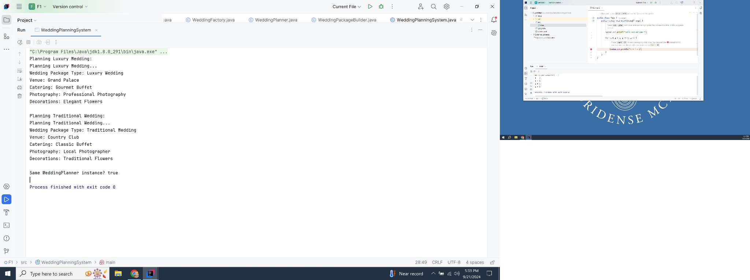

Problem 2 : Drone Management System

Overview:
You have been hired to develop a drone management system for a company that produces various types of drones for different purposes. The company works with multiple manufacturers, and each manufacturer produces different types of drones with specific capabilities. Your task is to create a flexible and extensible system that can handle different drone types (e.g., Surveillance Drones, Delivery Drones, Agricultural Drones) produced by different manufacturers, ensuring that the system can be easily expanded in the future.

Requirements:
- Drone Types: The company produces several types of drones:
  - Surveillance Drones: Used for monitoring and reconnaissance, equipped with high-quality cameras.
  - Delivery Drones: Designed to carry packages over short distances, equipped with payload-carrying mechanisms.
  - Agricultural Drones: Used for crop monitoring, irrigation, and pesticide spraying.
- Each drone type has certain characteristics such as:
  - Battery Capacity: The maximum battery life in mAh.
  - Flight Range: The distance the drone can cover in kilometers.
  - Special Features: A distinguishing feature of the drone (i.e camera quality or payload capacity or product being delivered).
- Manufacturers: Different manufacturers produce these drone types, but with varying specifications. For example:
  - Manufacturer A may focus on drones with longer flight ranges.
  - Manufacturer B may prioritize drones with higher battery capacities.
- Your system should account for these differences in drone specifications depending on the manufacturer.
- System Functionality:
  - The system should allow users to select a manufacturer.
  - The system should allow users to create different drone types (Surveillance, Delivery, Agricultural) for the selected manufacturer.
  - The system should display the specifications of the created drones, including battery capacity, flight range, and any special features.
- Extensibility: The company may add new drone types or manufacturers in the future, so your system should be designed to easily accommodate such changes without significant modifications.

Instructions:
- Drone Representation: Design a system to represent the different drone types and their unique characteristics. Your design should ensure that each drone type can have different values for battery capacity, flight range, and special features (described above) depending on the manufacturer.
- Manufacturer Representation: Your system should support the creation of drones by different manufacturers. Each manufacturer may have different specifications for the same drone type, so the system should reflect these variations. For this problem assume there are 2 ManufacturerA and ManufacturerB
- Drone Creation: The drone creation process should be centralized so that new drone types or new manufacturers can be added with minimal changes to the existing codebase.
- Output: The system should allow users to create drones of different types and manufacturers, and display their specifications. For example:
  - Surveillance Drone by ManufacturerA Battery: 4000 mAh, Range: 50 km, Special Feature: High-quality camera
  - Delivery Drone by ManufacturerB: Battery: 5000 mAh, Range: 40 km, Special Feature: High payload capacity
- Requirement: Think about how your system can be designed in a way that promotes flexibility and scalability.

Submission Requirements:
- Provide the full source code for your implementation, including a test case
- Include a short explanation of your design choices and how your system can be easily extended to support new drone types or manufacturers.
- If I want to extend the program by adding RescueDrones and ManufacturerC as new elements, how would they be integrated into your codebase? What design features make the codebase easier to extend?

Problem3: Product Customization and External Integration System

Overview
You are tasked with creating a product customization and integration system for a fictional online store. The system should allow customers to customize their products (e.g., laptops, smartphones) by selecting various specifications, and it should also retrieve product details from an external supplier’s database (in the form of a CSV file). The CSV file contains information about the default product models and their prices, which needs to be integrated into your system.
Hint : 2 patterns needed.

Requirements
- Product Customization:
  - Customers should be able to customize various products (e.g., laptops, smartphones) by selecting different specifications such as:
    - Laptops: Processor type, RAM size, storage size, graphics card, and operating system.
    - Smartphones: Screen size, processor type, camera resolution, battery size, and storage size.
  - Each product should have customizable attributes that can be selected step-by-step. All custom products are set to a fixed price of $800
- CSV Product Information Retrieval:
  - The system should retrieve the default product details (e.g., basic specifications and pricing) from an external CSV file provided by a third-party supplier.
  - The CSV file will contain information such as:
    - Product name
    - Default specifications
    - Pricing
- Integration:
  - The CSV file may contain product data in a different format than your internal system. You need to adapt the CSV data to work seamlessly with your internal product representation.
  - After retrieving and adapting the data from the CSV file, display both the customer’s customized product details and the default product details (from the CSV file) for comparison.
- Modularity:
  - Your system should be flexible enough to easily add new types of products in the future without requiring major changes to the codebase.

Task Requirements
- Product Customization:
  - Design a mechanism that allows customers to customize a product step-by-step, selecting different attributes.
  - Once all attributes are selected, the system should create a fully configured product and display the details.
- CSV Product Information Retrieval:
  - Design the system to retrieve product information from a CSV file that contains default specifications and pricing.
  - The system must be able to handle the CSV format and convert it to your internal product format.
- Integration:
  - Create a system that displays both the customized product and the default product from the external supplier (CSV data) side by side for comparison.
Sample CSV

Submission Requirements:
- Provide the full source code for your implementation, including a test case
- Include a short explanation of your design choices
Extra Credit [+5] : The stretch goal requires updating the logic to compare the custom product specifications with the default specifications in the CSV file, and if the custom product matches the Processor, RAM, and Storage of any product in the CSV, the system will adjust the price of the custom product to match that of the closest matching product in the CSV.
SAMPLE OUTPUT